1. <https://stackoverflow.com/questions/70608761/how-to-sign-an-ssl-certificate-for-an-ip-address>

or image:

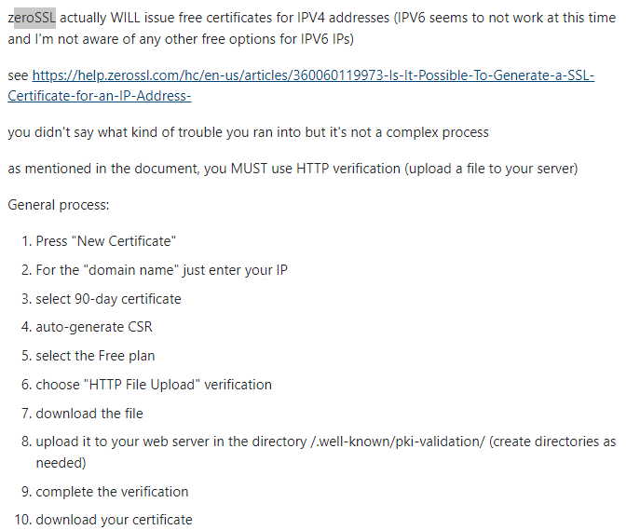

1. To Upload the HTTP File on the IIS web server: <https://www.ssldragon.com/blog/well-known-folder/>

Or image:  
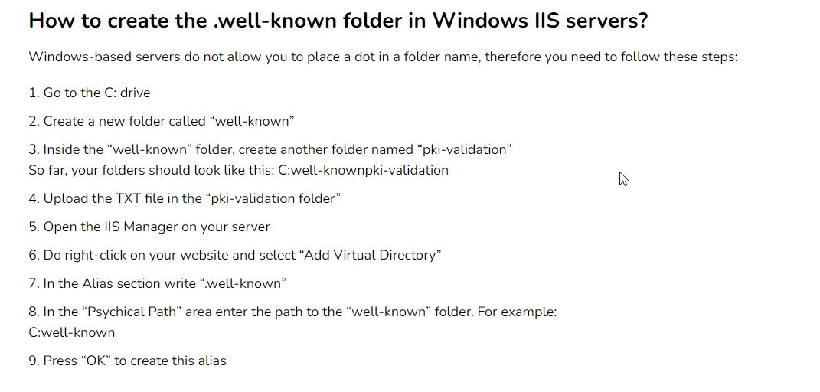

After this you will let zeroSSL to verify once done, it will make the folder and put the certificate.crt file in it, DOWNLOAD THE FOLDER.

1. You have to import the certificate into your IIS but it has to be in .pfx format not .crt so you have to download openSSL from here: <https://slproweb.com/products/Win32OpenSSL.html> and this is a tutorial on how to download/install openssl: <https://www.youtube.com/watch?v=jSkQ27sTto0>
2. Open cmd in the folder where the cerfticate.crt file is and run this command:

openssl pkcs12 -export -out certificate.pfx -inkey private.key -in certificate.crt  
  
During this process, you will be prompted to set a password for the exported **.pfx** file. Remember this password, as you'll need it during the IIS installation.

1. Once done copy the .pfx file to the server => open IIS => click on the server not the website => click import from the right side menu => import the certificate and put the password => click on web hosting not personal and Ok
2. Go to ur website => edit Bindings => add port 443 and HTTPS => choose the certificate and start the website mabrouk